HEIDENHAIN VT 122 and VTC software: the new measuring camera system for holistic tool evaluation

Tool presetting, tool magnification, and visual tool inspection: the VT 122 measuring camera and the VTC software from HEIDENHAIN are an intelligent system for all three tasks. The length and diameter of tools are measured automatedly. Using images directly from the machine's work envelope, the user can inspect the tools and measure the wear width on the control’s screen or from a computer in the office, without detouring to a measuring lab. The VT 122 measuring camera system thus shortens non-productive times, increases machining accuracy and reduces the scrapping and reworking of machined parts.

Three tasks for one intelligent system from HEIDENHAIN: the new VT 122 camera and the VTC software can be used for magnification, tool presetting and visual tool inspection. The tools are inspected entirely without contact. Images generated inside the machine's work envelope give an exact view of tool edges, providing the facts needed for holistic tool analysis.

New: automated tool measurement within the machine
The intelligent combination of camera and software for the TNC7 enables automated measurement of the length and diameter of the tool clamped in the tool spindle. The camera features an additional light unit for this purpose. The measuring camera system then sends the ascertained data to a HEIDENHAIN TNC control. That way there is no need to first determine the tool data by a separate tool presetter. This new function of the VT 122 measuring camera also ensures greater work safety because the tool clamped in the spindle can be checked again quickly and easily before machining. After machining, either a verification measurement can be performed, or simply a check for breakage.

This touchless measurement is suitable for delicate cutting edges of tools with a diameter of up to 100 mm. The VTC software works automatedly, so that, for example, cycles for the TNC controls can be used to perform the necessary measurements during night shifts. Tools that exceed typical wear limits can then automatically be disabled by the NC cycle. If a reference tool is available, the VT 122 can be used for measurement and compensation of thermal displacement of the tool axis.

Detailed tool inspection and wear width measurement
No measuring lab is needed when inspecting the tools and measuring the wear width directly from the images created within the machine. These images permit detailed documentation of the tool condition and wear status, as well as tool inspection before critical machining operations. This information is used to draw important conclusions about optimizing cutting parameters and NC programs. Of course each individual cutting edge can be inspected for breakage, and also the actual status can be checked upon expiration of the nominal tool life.

As part of the tool inspection, the camera takes close-up images of each tooth as well as detailed panoramic images of the entire tool circumference at different illumination angles. During inspection with the VTC software, the lighting angle can be varied for individual teeth. The panorama function of the VTC software generates images for intuitive inspection of the cutting edges and documentation of wear over time.

Also, tools can be imaged from below for a precise view of the tool tip. Visual tool inspection takes place conveniently on the control’s display screen, regardless of whether it is a HEIDENHAIN control or not. Inspections can also be performed at a later time with the PC software.

In the imaging cycle, the user can define which views should be created after the tool has been cleaned, as well as assign names for the image series, for structured work and targeted evaluation with the VTC software. The inspection overview is particularly useful for tools with many cutting edges. The user can navigate through each picture in the series, and a zoom window provides a magnified view. The overview can also be used to directly lock tools in the TNC's tool table.

Practical advantages
The vision systems not only help to avoid expensive damage to the tool, workpiece and machine, but the combination of automated cycles with tool presetting and microscopic visualization of tools also reduces TCO. Measuring the tools and creating the images within the machine offers numerous process advantages. For example, creating the images while the tool is in use within the machine leads to significant time savings. Also, there are fewer influences on the process, since the tool does not cool down, as occurs during microscope inspection in a lab. Tool evaluation is faster, processes become more productive and there is automated documentation of the tool condition and wear development.

Installation and operation of the VT 122 measuring camera
The sealed and highly rugged VT 122 vision system is designed to be installed inside the machine’s work envelope. It requires purge air only during tool cleaning cycles. It can be employed regardless of whether cooling lubricant is used or dry machining is performed. Its integrated jets use purge air to clean the tools to be inspected and the cameras' cover glasses. An optimal cleaning strategy makes it possible to remove nearly all chips. The user can exchange the cover glasses of the two cameras in the machine if needed.

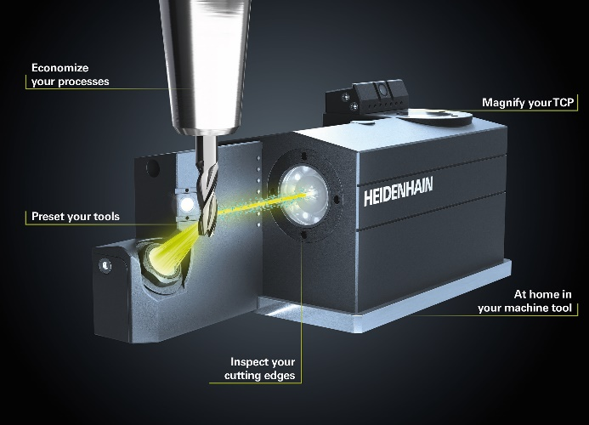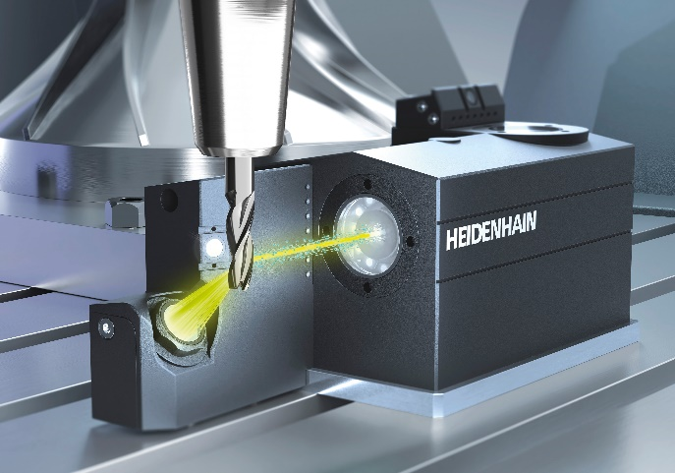 | Three tasks in one solution for tool inspection: magnify, inspect and preset with the VT 122 measuring camera and intelligent VTC software from HEIDENHAIN.

For more information, visit:  live.heidenhain.com  www.heidenhain.com/tnc7  www.heidenhain.com | Contact person for the trade press:  Ulrich Poestgens  DR. JOHANNES HEIDENHAIN GmbH  Dr.-Johannes-Heidenhain-Straße 5  83301 Traunreut, GERMANY  Tel.: +49 8669 31-4154  poestgens@heidenhain.de

